Scholarship Information for Teachers and Students

This is for all scholarships except the Columbia Center Rotary Award for Vocational Excellences (RAVE). That scholarship is still the old process as it is externally reviewed. See below for info on this award.

Scholarship section of our new online APPLY system is open now[. Tritech.smapply.io](tritech.smapply.io) or on the website <tritech.ksd.org>

Students need to register for an account. On the eligibility they need to put 12 or are seniors. They also need to select their current program as that will dictate what they are eligible to apply for as well as send it to the teacher for recommendations. They can do more than one scholarship application but they will have to do them separately. They will also have to submit the documents each time. Encourage them to write down the questions and then do a word document to spell check and edit then copy/paste in each application.

It will be **open for student applications through March 6th at 4pm**. Teachers can monitor students that come in between now and March 6th. Students must upload their resume and copy of current attendance/grades as two separate documents. They can’t submit the application until the application is completed.

**Teacher reviews and recommendations must be completed by Friday, March 13th** Teachers are all in as reviewers. You should have received an invitation to tritech.smapply.io Teachers will have a list of students to review and add recommendations for. Once completed the student applications will be forwarded to the site council member who will be reviewing that group.

Columbia Center Rotary Award for Vocational Excellence (RAVE) $2,000 scholarships

2020 application is located on shared drive 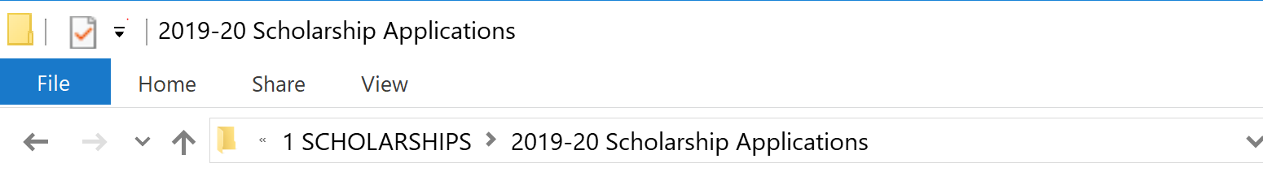

2020 Columbia Center Rotary Scholarship (PDF) fillable form

Students need to complete the completed application, resume, letter of recommendation and transcript electronically to Karen Suhr by March 6th as well (even though the application says March 22nd-that is when we will have them to Columbia Center Rotary). Students **should not submit** them directly to Amanda Heap.